SW Engineering CSC648/848

Task Flow

Section 1, Team 4

12/02/2024

Team Members:

Team Leader - Bisum

Front End - Zoe, Sanna

Back End - Anisah, Jun

Scrum Master - Josh

Table of Contents

**Unit Tests 3**

**Integration Tests 4**

**Coding Practices 4**

# Unit Tests

1. P1 Features to be Tested
   1. Registration
      1. Should return 201 for successful registration
      2. Should return 400 for missing values

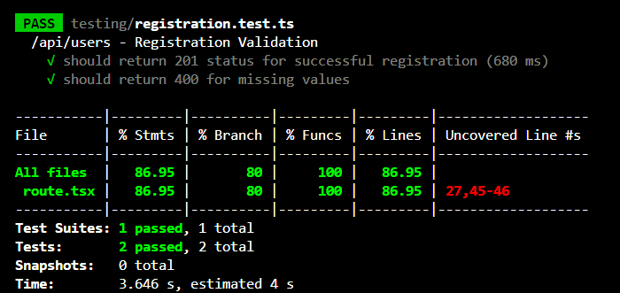

* 1. Login
     1. Should return 401 for invalid credentials
     2. Should return 400 for empty fields

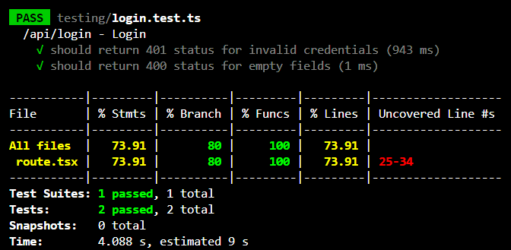

* 1. Tasks
     1. Should return 201 for successful task addition
     2. Should return 201 for fetching task
     3. Should return 400 for missing required fields

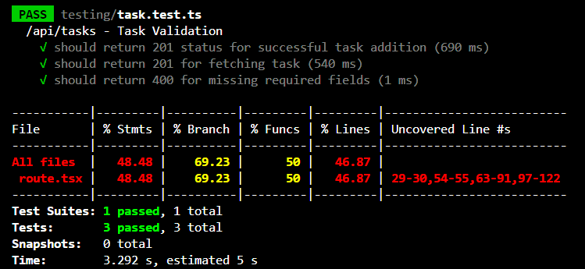

Github URL: <https://github.com/CSC-648-SFSU/csc648-01-fa24-team04/tree/development/application/nextjs-project/testing>

Testing Software Used: Jest

# Integration Tests

[Please refer to the attached google excel sheet in the email.]

Coverage Analysis

* 1. Total Features Tested: 10
  2. Features Passed: 9/10
  3. Summary: All of our features work as expected, except for un-completing tasks. Our team is still implementing that feature and it should be done by the final demo

# Coding Practices

Coding Style

1. Style Guide Used: ESLint with TypeScript configuration, following best practices for TypeScript.
2. Tool/Plugin for Enforcement: ESLint, configured for TypeScript.
3. Details: ESLint rules are configured to enforce consistent TypeScript coding style, such as variable naming conventions, proper indentation, and avoiding unused variables. This helps maintain readability and catch potential issues early in development.